Assessment Schedule – 2016

Mathematics and Statistics: Apply algebraic methods in solving problems (91261)
Evidence Statement
Q | Expected Coverage | Achievement (u) | Merit (r) | Excellence (t)
ONE  (a) | 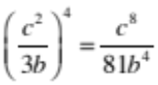 | Negative or fourth power correctly used. | Correct answer.
(b) | x² – 8x + 10 = (x – 4)² – 6 | Correct arrangement or p and q given.  (p = 4 and q = –6 not required)
(c)(i) | When x² + x – 56 = 0  (x + 8)(x – 7) = 0  x = –8 or 7.  When 4x² + x – 14 = 0  (4x – 7)(x + 2) = 0  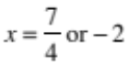  So the solutions of the first quadratic are four times those of the second. | Both equations factorised correctly if solution is incorrect. | Both quadratics solved and relationship stated.
(c)(ii) | Solutions of dx² + ex + f = 0  are 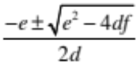  and those of x² + ex + df = 0  are 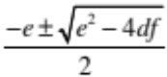  So the solutions of the second quadratic are d times those of the first. | One set of solutions found. | All solutions found. | Devised a strategy and developed a chain of logical reasoning to solve the problem.
(d) | 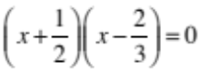  (2x + 1)(3x – 2) = 0  6x² – x – 2 = 0  So a = 6, b = –1 and c = –2  or any other correct values of a, b, and c. | Quadratic found with correct values of a, b, and c. | Correct values of a, b and c stated.
(e) | To have rational roots, the discriminant is  - ≥ 0 (accept > 0 at achieved and merit)  - a perfect square  Hence  16k² – 4 × 2(2k² + 3k – 11) ≥ 0  –24k + 88 ≥ 0, k ≤ 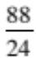 or 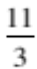  Cases, k integer  k = 0 not possible as told k positive  k = 1, ∆ = 64 which is a square  k = 2, ∆ = 40 which is not a square  k = 3, ∆ = 16 which is a square  k ≥ 4 not possible as ∆ negative  So only possible values are k = 1 or 3. | Values substituted into discriminant. | k ≤ or unsimplified.  OR One value for k found with reason.  OR  Discriminant used correctly with one restriction on k given. | Both values of k found with logical chain of reasoning.

NØ | N1 | N2 | A3 | A4 | M5 | M6 | E7 | E8
No response; no relevant evidence. | Attempt at ONE question. | 1 of u OR partial solution in TWO questions. | 2 of u | 3 of u | 1 of r | 2 of r | 1 of t | 2 of t

Q | Expected Coverage | Achievement (u) | Merit (r) | Excellence (t)
TWO  (a) | x² – 10x – 3 = 0  discriminant = 100 + 4 × 3  = 112 | Correct discriminant found.
(b) | 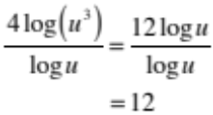 | Power rule for logs in numerator used. | Correct answer.
(c) | 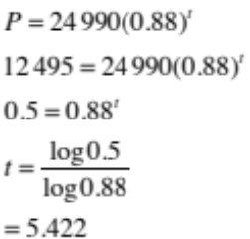  So it takes 5.422 years to halve in value. | CAO or equation set up and error made in solving. | Correct equation solved to find value of t.  Accept t = 6 if working shown.
(d)(i) | 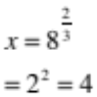 | Correct value found.
(d)(ii) | 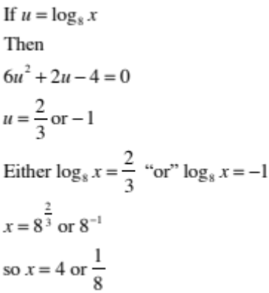 | CAO.  OR  Quadratic formed.. | Both values for u found. | Devised a strategy and developed a chain of logical reasoning to solve the problem.  Both values of x found.
(e) | Let the sides of the triangle be 3y, 4y, and 5y for some real positive number y.  Area of triangle is  ½ × 3y × 4y = 6y²  Path has width 1.  So path area is 12y + π  2(12y + π) – 6y² = 2π  24y + 2π – 6y² – 2π = 0  24y – 6y² = 0  6y(4 – y) = 0  So y = 4 ( as can’t be 0)  and length of longest side of triangle is 5 × 4 = 20 m.  (Longest side 22.35m accepted as an alternative interpretation.) | Quadratic established. | Quadratic solved for y, or consistently solved from incorrect quadratic. | Correctly solved and dimensions given.

NØ | N1 | N2 | A3 | A4 | M5 | M6 | E7 | E8
No response; no relevant evidence. | Attempt at ONE question. | 1 of u OR partial solution in TWO questions. | 2 of u | 3 of u | 1 of r | 2 of r | 1 of t | 2 of t

 | Expected Coverage | Achievement (u) | Merit (r) | Excellence (t)
THREE  (a) | 12x² – x – 6 = (4x –3)(3x + 2)  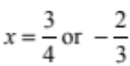 | Correct solutions.
(b) | log_{x}216 = 3  x³ = 216  so x = 6 or 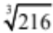 | Correct answer.
( c) | 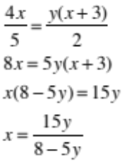 | Terms involving x collected to one side. | Correctly solved.
(d) | 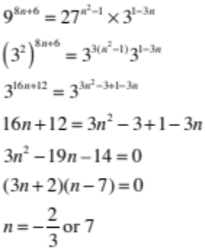 | Base changed to 3 in all terms. | Quadratic established. | Devised a strategy and developed a chain of logical reasoning to solve the problem. Correct values for n found.
(e)(i) | Assuming origin is at the centre of the bridge, vertex of middle parabola is (0,3), so form of parabola is y = ax² + 3  x = 20, y = 15 gives  15 = a(400) + 3  So a = 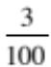  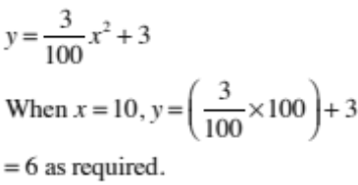 |  | Equation formed and  y = 6 when x = 10 shown.
(e)(ii) | For the second parabola on right using the same origin.  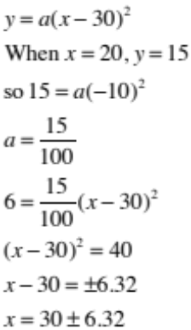  x = 30 – 6.32, as other value beyond end of bridge.  So x = 23.575 metres  and the horizontal distance is 23.675 – 10  or 13.675 metres. |  | Model for second parabola given and used to find value of x.  (Accept other forms of parabolas.) | Devised a strategy and developed a chain of logical reasoning to solve the problem.  Correct length found.

NØ | N1 | N2 | A3 | A4 | M5 | M6 | E7 | E8
No response; no relevant evidence. | Attempt at ONE question. | 1 of u OR partial solution in TWO questions. | 2 of u | 3 of u | 1 of r | 2 of r | 1 of t | 2 of t

Cut Scores
Not Achieved | Achievement | Achievement with Merit | Achievement with Excellence
0–7 | 8–13 | 14–19 | 20–24

